Promoting Sustainability and Affordability Through

AI-Enhanced Student Marketplaces focusing

on economic sharing

Devansh Bansal  
CSE(AIML)  
KIET GROUP OF INSTITUTIONSGHAZIABAD  
[devanshbansal2021@gmail.com](mailto:devanshbansal2021@gmail.com)

Rohan Rathi  
CSE(AIML)  
KIET GROUP OF INSTITUTIONS  
GHAZIABAD  
[rohanrathi2407@gmail.com](mailto:rohanrathi2407@gmail.com)

Devanshu Saxena   
CSE(AIML)  
KIET GROUP OF INSTITUTIONSGHAZIABAD  
[devanshucodes@gmail.com](mailto:devanshucodes@gmail.com)

Anjali Maurya  
CSE(AIML)  
KIET GROUP OF INSTITUTIONSGHAZIABAD  
anjalimaurya0281@gmail.com

Divya Bansal   
CSE(AIML)  
KIET GROUP OF INSTITUTIONSGHAZIABAD  
[divyabansal1010@gmail.com](mailto:divyabansal1010@gmail.com)

*Abstract--- This research proposes the design and development of ReStore, an AI-enabled marketplace for students of KIET Group of Institutions, which seeks to narrow the consumption gap and foster sustainable use of resources on college campuses. The platform allows students, especially outgoing seniors, to sell second-hand books, appliances, and furniture, as well as verified listings of PGs, hostels, and flats located around the campus. ReStore implements a real-time bidding system for price gauging and transaction equity. Financial and logistical constraints severely limit college students’ access to necessary goods and accommodation’s relative to their campuses. This paper presents an AI-powered web application designed especially for students of KIET that provides a platform for second hand goods exchanges, PG listings, and dynamic bidding functionalities. Building upon similar initiatives such as ShareSpace, the project ReStore aims to further sustainability and affordability through economic sharing moderated by Artificial Intelligence. This study demonstrates the applicability of a localized AI-assisted e-commerce system to enhance resource-sharing among students, reduce excess environmental waste, and support sustainable practices—creating scaled solutions tailored for deployment in other academic environments (Tiwari et al., 2023).*

*General Term—*

*Student-Centric Systems, AI Integration, Resource Optimization.*

*Keywords—*

*Student Marketplace, Sustainability, Economic Sharing, AI Moderation, Second-Hand Trading, PG Listings*

Introduction

It's common for college students to look for campus related items like furniture and textbooks at an affordable price which is often hard to come by. ReStore provides this specific solution by enabling students to easily buy and sell second-hand goods within their college community. There is a gap in holistic-multidimensional approaches to student housing, and goods acquisition which leads to siloed devices

working independently with very little collaboration. This is a problem of great magnitude that can be tackled using technology. ReStore is developed for *KIET Group of Institutions* serves as a student fulfils their requirements by allowing them to post and bid or buy/sell second-hand items. In addition, this platform also has a housing module to list PG/hostel vacancies.

There is demand from academic communities to support students especially with resourced practices that students can easily adopt. Sustaining efforts within liberal environments require students to develop resource-efficient, shared solutions (SCORAI, 2022). More often than not, students put aside their furniture and textbooks in waste as there is no means of eco-friendly capitalism for supporting waste reduction. Many AI facilitated student marketplaces provide a solution through enabling a support community focused on affordability, and strong economy.

In this paper, we examine the consequences of ReStore, an AI-backed instrument intended specifically for students to buy and sell second-hand items and rent out dorm rooms. To accommodate the needs of students, ReStore has several important features: an auction-style pricing model with real-time updates that ensures fairness in pricing, a PG Connect module that provides verified listings of hostels and PGs within a reasonable vicinity, and advanced encryption technology for secure login, as well as AI personalization algorithms for customized recommendations based on past actions and future trends. Furthermore, blockage of access routes to multi-PGs in lack of organized systems tailored to student challenges require facing numerous obstacles. The methods that students use to locate PGs are unstructured and largely informal. Students have no other means available other than relying on loose social media groups, inconsistently maintained online portals, or incomplete word of mouth, which invariably results in waste of precious time.

Additionally, graduating students often leave behind usable items, which either go to waste or fail to reach those who could benefit from them, creating a gap between supply and demand within the student community itself.

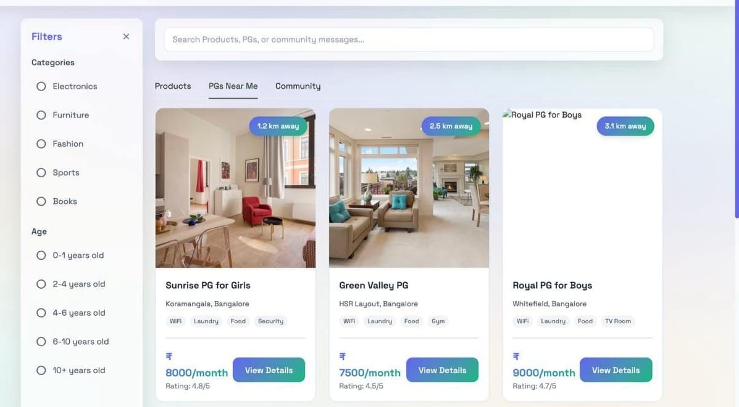

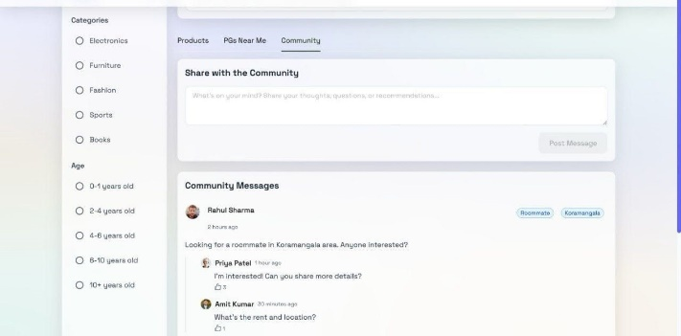

# ***LITERATURE REVIEW***

Inspired by the rise of circular economies, ShareSpace was innovated, being special for campus-oriented e-commerce. Listed, OLX, Facebook Marketplace, and eBay provide wide-ranging functionalities but do not work for closed communities. The campus setting has been scrutinized by both Wei et al. (2023) and Miah et al. (2014), mostly with public discussions on idle goods; presumably, they also provide an economic and environmental perspective.

In a comparison of trusts, identity verification, and AI moderation, ReStore stands apart. This system even supports auctioning for housing, as well as map-based housing search, which general platforms lack. ReStore is designed to ensure intuitive experience for its users through modern web technologies and simultaneously is affordable and sustainable.

The ReStore platform at KIET Group of Institutions addresses the growing need for accessible and sustainable solutions within student communities. Existing e-commerce platforms like eBay and Craigslist offer a broad marketplace for second-hand goods, but they lack the targeted focus and community trust essential for a college environment. These platforms often fail to address the specific logistical challenges and trust issues faced by students, such as item pickup, payment security, and verification of sellers. Marketplaces for students, although very close to the actual target users, typically are not equipped with features such as bidding and housing solutions, which the market generally requires.

With the development of the sharing economy, collaborative consumption and sustainability have gained paramount importance. Studies have shown that reducing consumption in the first instance through reuse and recycling considerably shrinks environmental footprints. ReStore works against this trend by promoting circularity within campus activities at the KIET level as a means of reusing textbooks, furniture, and other basic necessities. The presence of a bidding system on this platform creates an inherent mechanism for price discovery that ensures fairness and transparency in juxtaposition to other general classified platforms, which are often sorely lacking in these.

ReStore tackles yet another issue with student housing. The online present housing platforms provide the scaffold for listings but are generally without much additional useful information or any level of community feedback. Students have difficulty finding cheap and good accommodation near campus. By the integration of the PG connect module, ReStore will offer trustworthy listings and geoservice to ease this difficult process. Location-based services, especially map integration, have become most effective with user experiment in multiple platforms aimed at students.

Online engagement is critical in uniting the student community. Social network research suggests the importance of an online environment for communication and cooperation. The platform seeks to offer social relations among KIET students, thus providing a safe and engaging working environment. User authentication and data security are key concerns; hence, good practices while implementing security-based authentication systems shall go a long way in generating trust.

ReactJS, NodeJS, MongoDB, and ExpressJS were selected for ReStore because of their great potential in scalability, performance, and building modern web applications. These technologies help in building an intuitive and user-friendly interface, very crucial for maximizing interactivity among users. The principles of user experience or UX design should guarantee that the user finds the platform easy to navigate and use.

Basically, ReStore attempts to address the shortcomings of other platforms by offering an all-around option combining the second-hand market with the PG connect module, a system that promotes affordability, sustainability, and community on the KIET campus. ReStore, by way of modern web technology coupled with the emphasis on user experience, is intended to serve as a useful tool for students.

# ***APPLICATION CHALLENGES***

Maintaining user engagement over time is one of the largest challenges. It can be difficult to sustain a consistent flow of listings and active participation from both buyers and sellers after the initial excitement subsides. Keeping track of and regulating the content that is posted on the platform presents another difficulty. There is always a chance of inaccurate or inappropriate listings because it is student-driven. A large portion of the process currently uses manual review, which isn't always scalable or dependable, even though AI-based moderation is on the horizon.

It's critical that these listings are current, safe, and accurate. At the moment, this mainly relies on users giving truthful feedback, which makes maintaining quality difficult. Due to ReStore's current lack of a payment gateway, transactions are limited to in-person cash exchanges. This limits the platform's ability to grow to include remote buyers in addition to decreasing convenience.

Additionally, as the platform expands, it will be necessary to secure user data, plan for scalability, and guarantee a seamless user experience. In order to make ReStore a reliable, long-term solution for student communities, these problems must be addressed.

# ***METHODOLOGY***

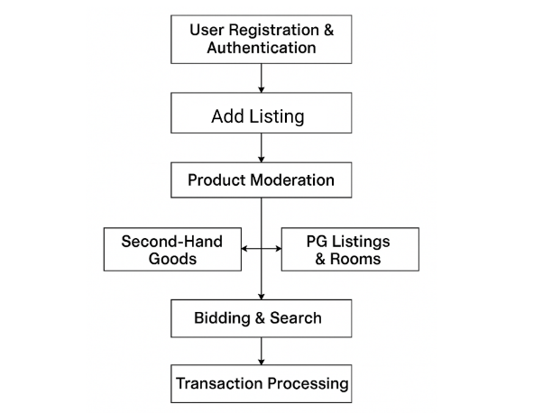

# ***IMPLEMENTATION***

1. **ADD LISTING**

Users are able to add new listings to the platform after successfully registration and authentication. These listings include secondhand selling items such as books, electronics, furniture, as well as accommodation services like PG/hostel beds and rooms. Users provide detailed descriptions, relevant photographs, clearly stated prices, location, and relevant dates for availability. To guarantee certain quality standards, certain fields marked as mandatory need to be filled during listing creation process which would guarantee that all posts are standardized.

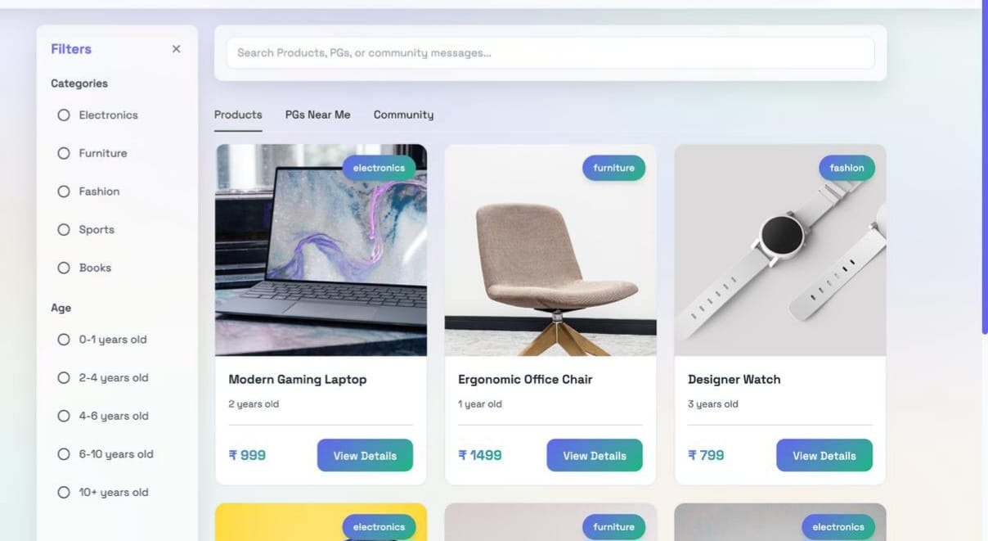

# **PRODUCT MODERATION**

A listing goes through a moderation process after it is submitted. Administrators check listings for appropriateness, authenticity, and adherence to platform guidelines. By removing spam, fraud or inappropriate content, the marketplace's integrity and legitimacy is maintained.  
  
Depending on the size of the project, the administrators may choose to do this manually or by using automated moderation algorithms. One feature that will be added in the future is AI-assisted moderation.

1. **CATEGORIZATION**

After the moderation process, listings are divided into two main categories: PG Listings and Second-Handed Goods.   
  
Second-Hand Goods: include Items like electronics, books, and other necessities are up for auction or sale.   
  
PG Listings & Rooms: include Students seeking accommodation can find verified PG or hostel listings, complete with rent details, amenities in proximity to educational institutions.

* **BIDDING AND SEARCH MECHANISM**

The platform includes a real-time bidding system for used goods, enabling users to make bids within a defined time limit. The seller can view bids as they arrive and, then, either accept, ignore, or negotiate with the bidder to settle on a price by contacting them.

As users search and filter listings, the AI-enhanced algorithms account for their preferences and prior behavior (Kaur et al., 2023), resulting in unmatched relevancy on the listings. Browsing becomes seamless and custom to each user experience, as listings are available by using smart-search features.

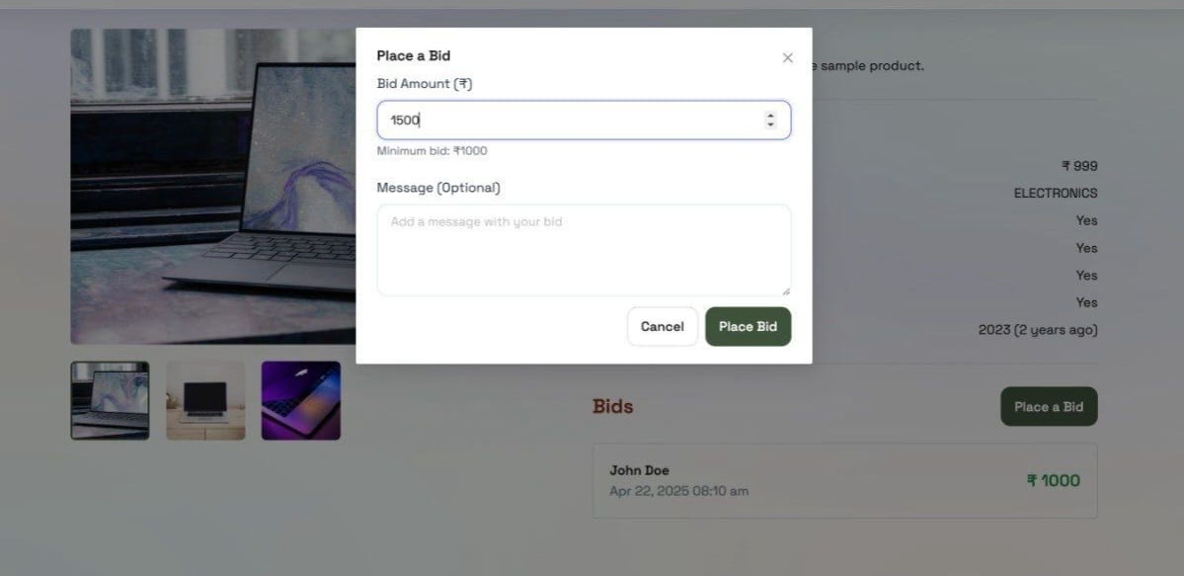

# **TRANSACTION PROCESSING**

The system enables the completion of the transaction after bidding finishes or direct purchase agreements are made. Since the payment methods are not integrated into the platform, the buyers have to contact the sellers directly to settle payment for the goods purchased outside the platform.

**Database Integration**

With user profiles, product and PG accommodation listings, as well as bidding information, the ReStore platform manages the data using the scalable NoSQL database, MongoDB. Each user has a listing that is securely stored, alongside its’ metadata images, pricing, and timestamps. Bidding activities are also updated in real-time, ensuring that there is no disruption in the users’ transaction experiences.

Apart from data storage purposes, MongoDB also aids the recommendation system of the platform. Current users’ activities like items they have already viewed and search patterns are used to make suggestions for products and PG listings specially curated for them. This surpasses user retention levels, enabling easier access to products and enhancing the personalization of marketplace experiences.

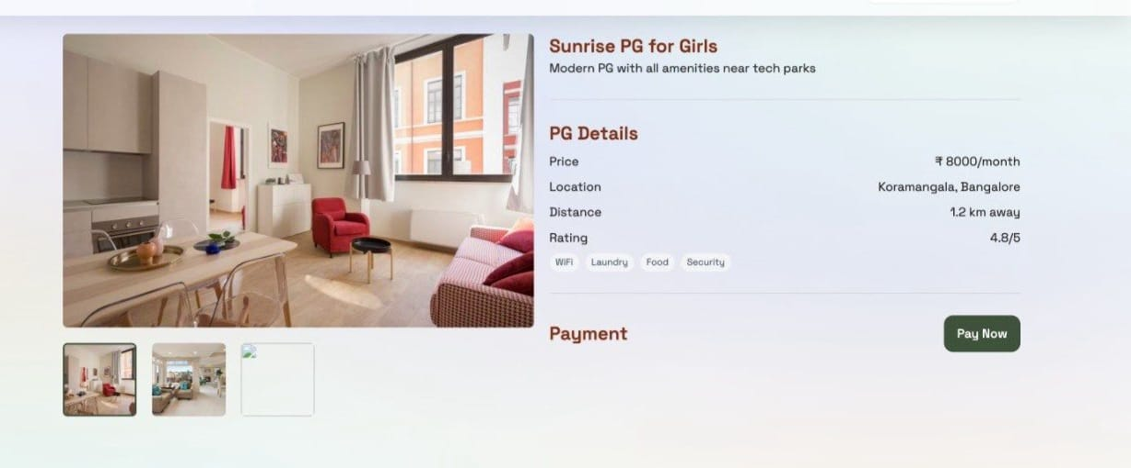

**Technology Stack**

The following technologies were used in the development of ReStore:

Google Maps API- Used to display the location of PG's and hostels.

Web Sockets- Used to create the real time bidding system.

**Frontend:**

ReactJS- A JavaScript library for building user interfaces.

**Backend:**

NodeJS- A JavaScript runtime environment.

ExpressJS- A web application framework for NodeJS.

**Database:**

MongoDB- A NoSQL database.

**Image Management:**

Cloudinary- Cloud based image and video management.

Multer- Node.js middleware for handling multipart/form-data.

**Version Control:**

Git- For code versioning and collaboration.

## **Result Analysis**

Through an online space for students, ReStore connects the campus community with affordable and accessible opportunities. An integration of modern technology stacks with envisioned AI functionalities is therefore a scalable framework for sustainable campus commerce. As ReStore further develops its best practices in moderation, payment solutions, and expansion plans, it will build an ideal national model for student-community interactions.

Multiple enhancements will be implemented to improve the platform architecture within the following releases so that it can provide secure and dependable online transaction services via the integration of a payment gateway. Developing a mobile app will further boost platform accessibility by providing mobility-based ease for interaction for the students. Under the PG Connect module, the housing search experiences will be enriched with more details about amenities, virtual tours, plus direct messaging options between PG owners and seekers.

The integration also plans to include AI-based recommendation systems to provide sound suggestions and tracking systems showing the environmental impact of recycled products. Through these improvements, the ultimate goal is to create a user-centric ecosystem that complements and reinforces ReStore's strategic role in academic communities.

##### **Conclusion**

ReStore manages to solve the dual crises of affordability and sustainability within college neighborhoods by providing a student-first second-hand product-and-accommodation exchange. Real-time bidding, AI recommendations, and secured user verification all aid the circular economy design to suit student needs.

Looking into the future, numerous enhancements are underway to further empower the platform's influence. These improvements include the birth of a mobile application for ease of use and an extension to the PG connect module featuring virtual tours and direct messaging. Alongside these, an AI-based recommendation engine will drive both personalization and environmental awareness (Hartmann & Becker, 2024). With these fills, ReStore can truly become the national template for student-driven economic sharing and sustainable digital ecosystems.

**References**

[1] Faiz Ahmed, Nitin Kumar Jha, Md Faizan, "Design and

Development of a Localized E-Commerce Solution for Students Focusing on Economical Sharing," VIT Chennai, 2024.

[2] Miah, M., "Social Website for Buying, Selling, and Trading Textbooks in Campus," IJISCS, 2014.

[3] Wei, S.J. et al., "Research on the Practice of College Students’ Second-Hand Trading Platform," Open Access Library Journal,

2023.

[4] Giri, A.S. et al., "Campus Second-Hand Buy and Sell Application, " IJRASET, 2022.

[5] Novgorodtseva, A.N. et al., "Online Marketplace: Student Consumer Strategies," Economic Consultant, 2020.

[6] Ramandeep Kaur, Ishika Tripathi, Inderjot Singh Saini,

Anugrah Carlose Earnest, Roshan Jose "Transforming the Second-Hand Marketplace: An Analysis of a Website's Role in Facilitating Buying, Selling, Donating, and Renting of Used Items" SSRN, 2023.

[7] Sustainable Consumption Research and Action Initiative (SCORAI) "AI-Powered Circular Economies: Enhancing Second-Hand Platforms for Sustainable Consumption" SCORAI Proceedings, 2022.

[8] Karen Lee, Tanvir Hussain "Sustainable E-commerce Marketplace: Reshaping Consumer Behavior Towards Second-Hand Goods" Springer, Smart Innovation Systems and Technologies, 2023.

[9] Sciling AI "AI in the Second-Hand Market: A Sustainable Alternative to Fast Fashion" Sciling Interfaces de Futuro, 2021.

[10] R. Tiwari, P. Lamba, A. Deshmukh "AI-Powered Student Ecosystems: Enabling Resource Sharing and Sustainable Growth on Campus" IJICTRD, 2023.

[11] Silvia Hartmann, Daniel Becker "AI and the Sharing Economy: Enhancing Trust and Efficiency in Peer-to-Peer Student Markets" International Journal of Digital Economy, 2024.

[12] Yue Zhao, Lijun Zhang "Campus Resource Exchange and AI: Redesigning Platforms for Affordability and Sustainability" Open Access Journal of Information Systems, 2024